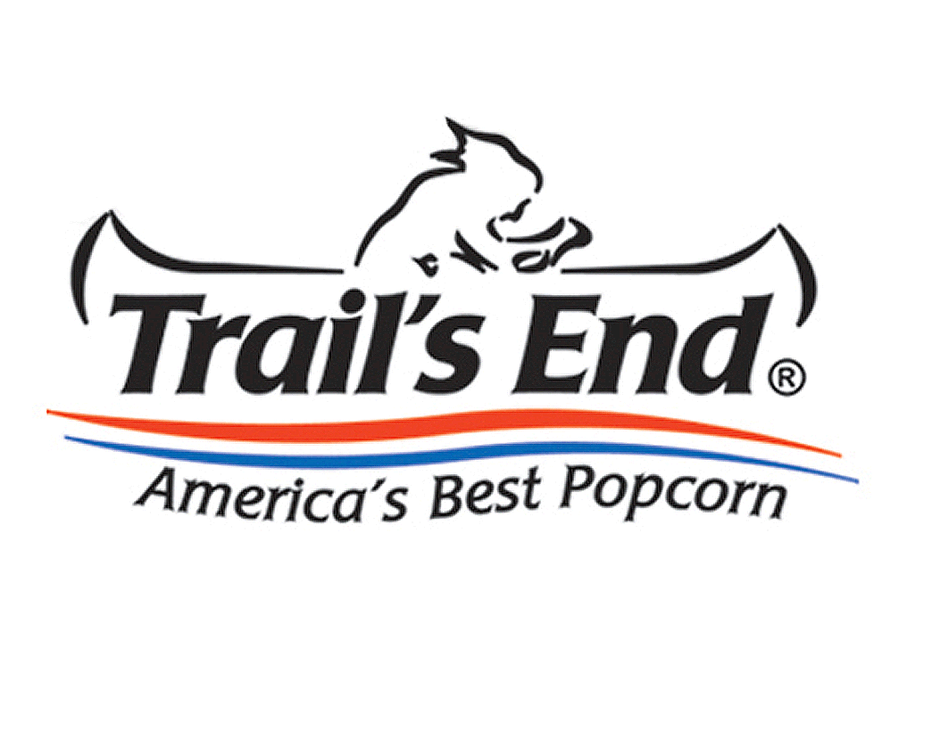**Show and Deliver Product Receipt – Fall 2024**

Scout Name: _______________________ Den/Patrol: ________

Date: _____________________________________

I acknowledge receipt and financial responsibility for the popcorn listed.

(Signature – must be 18 or older) Name (please print)

|  |  |  |  |  |  |  |  |
| --- | --- | --- | --- | --- | --- | --- | --- |
| **Item Name** | **Individual Items** | | | **Cost**  **per**  **Item** | **Received Value**  **(# x Cost)** | **Returned**  **Value**  **(# x Cost)** | **Sold**  **Value**  **(# x Cost)** |
| **Received** | **- Returned** | **= Sold** |
| **Chocolatey Pretzels** |  |  |  | **$25** |  |  |  |
| **S’mores Popcorn** |  |  |  | **$25** |  |  |  |
| **Unb. Butter Microwave** |  |  |  | **$25** |  |  |  |
| **Salted Caramel Corn** |  |  |  | **$25** |  |  |  |
| **White Cheddar Cheese** |  |  |  | **$20** |  |  |  |
| **Popping Corn** |  |  |  | **$17** |  |  |  |
| **Kettle Corn** |  |  |  | **$15** |  |  |  |
|  |  |  |  |  |  |  |  |
|  |  |  |  |  |  |  |  |
| **TOTAL Picked Up/Returned/Sold:** | | | | |  |  |  |
| **Donations** | | | | | | |  |

**Handling/Storage of Popcorn (You are responsible for product damaged or lost after pickup):**

* Do not store popcorn at temperatures above 70 degrees Fahrenheit (the chocolate items melt).
* Do not store in direct sunlight.
* Do not handle in a rough manner.
* Do not store the product in damp conditions.

**NOTES:**

* ***If you believe that you will be unable to sell the product you have picked up today, please return it to the Popcorn Chair ASAP so that it can be made available to another Scout to sell.***
* All unsold merchandise must be physically returned to the pickup location by the designated date so that we can return the product to the Council.
  + You can return any product, but the individual containers must not be opened.
  + Product must not be damaged, melted, crushed.

Popcorn Chair Copy

|  |  |  |  |  |
| --- | --- | --- | --- | --- |
| I acknowledge the receipt of the following interim cash and checks on the dates listed. | Date | Amount | Date | Amount |
|  |  |  |  |
| Signed: |  |  |  |  |

**Show and Deliver Product Receipt – Fall 2024**

Scout Name: _______________________ Den/Patrol: ________

Date: _____________________________________

I acknowledge receipt and financial responsibility for the popcorn listed.

(Signature – must be 18 or older) Name (please print)

|  |  |  |  |  |  |  |  |
| --- | --- | --- | --- | --- | --- | --- | --- |
| **Item Name** | **Individual Items** | | | **Cost**  **per**  **Item** | **Received Value**  **(# x Cost)** | **Returned**  **Value**  **(# x Cost)** | **Sold**  **Value**  **(# x Cost)** |
| **Received** | **- Returned** | **= Sold** |
| **Chocolatey Pretzels** |  |  |  | **$25** |  |  |  |
| **S’mores Popcorn** |  |  |  | **$25** |  |  |  |
| **Unb. Butter Microwave** |  |  |  | **$25** |  |  |  |
| **Salted Caramel Corn** |  |  |  | **$25** |  |  |  |
| **White Cheddar Cheese** |  |  |  | **$20** |  |  |  |
| **Popping Corn** |  |  |  | **$17** |  |  |  |
| **Kettle Corn** |  |  |  | **$15** |  |  |  |
|  |  |  |  |  |  |  |  |
|  |  |  |  |  |  |  |  |
| **TOTAL Picked Up/Returned/Sold:** | | | | |  |  |  |
| **Donations** | | | | | | |  |

**Handling/Storage of Popcorn (You are responsible for product damaged or lost after pickup):**

* Do not store popcorn at temperatures above 70 degrees Fahrenheit (the chocolate items melt).
* Do not store in direct sunlight.
* Do not handle in a rough manner.
* Do not store the product in damp conditions.

**NOTES:**

* ***If you believe that you will be unable to sell the product you have picked up today, please return it to the Popcorn Chair ASAP so that it can be made available to another Scout to sell.***
* All unsold merchandise must be physically returned to the pickup location by the designated date so that we can return the product to the Council.
  + You can return any product, but the individual containers must not be opened.
  + Product must not be damaged, melted, crushed.

|  |  |  |  |  |
| --- | --- | --- | --- | --- |
| I acknowledge the receipt of the following interim cash and checks on the dates listed. | Date | Amount | Date | Amount |
|  |  |  |  |
| Signed:  Popcorn Chair Copy |  |  |  |  |

**Show and Deliver Product Receipt – Fall 2024**

Scout Name: _______________________ Den/Patrol: ________

Date: _____________________________________

I acknowledge receipt and financial responsibility for the popcorn listed.

(Signature – must be 18 or older) Name (please print)

|  |  |  |  |  |  |  |  |
| --- | --- | --- | --- | --- | --- | --- | --- |
| **Item Name** | **Individual Items** | | | **Cost**  **per**  **Item** | **Received Value**  **(# x Cost)** | **Returned**  **Value**  **(# x Cost)** | **Sold**  **Value**  **(# x Cost)** |
| **Received** | **- Returned** | **= Sold** |
| **Chocolatey Pretzels** |  |  |  | **$25** |  |  |  |
| **S’mores Popcorn** |  |  |  | **$25** |  |  |  |
| **Unb. Butter Microwave** |  |  |  | **$25** |  |  |  |
| **Salted Caramel Corn** |  |  |  | **$25** |  |  |  |
| **White Cheddar Cheese** |  |  |  | **$20** |  |  |  |
| **Popping Corn** |  |  |  | **$17** |  |  |  |
| **Kettle Corn** |  |  |  | **$15** |  |  |  |
|  |  |  |  |  |  |  |  |
|  |  |  |  |  |  |  |  |
| **TOTAL Picked Up/Returned/Sold:** | | | | |  |  |  |
| **Donations** | | | | | | |  |

**Handling/Storage of Popcorn (You are responsible for product damaged or lost after pickup):**

* Do not store popcorn at temperatures above 70 degrees Fahrenheit (the chocolate items melt)
* Do not store in direct sunlight.
* Do not handle in a rough manner.
* Do not store the product in damp conditions.

**NOTES:**

* ***If you believe that you will be unable to sell the product you have picked up today, please return it to the Popcorn Chair ASAP so that it can be made available to another Scout to sell.***
* All unsold merchandise must be physically returned to the pickup location by the designated date so that we can return the product to the Council.
  + You can return any product, but the individual containers must not be opened.
  + Product must not be damaged, melted, crushed.

|  |  |  |  |  |
| --- | --- | --- | --- | --- |
| I acknowledge the receipt of the following interim cash and checks on the dates listed. | Date | Amount | Date | Amount |
|  |  |  |  |
| Signed:  Scout Final Copy |  |  |  |  |

**Show and Deliver Product Receipt – Fall 2024**

Scout Name: _______________________ Den/Patrol: ________

Date: _____________________________________

I acknowledge receipt and financial responsibility for the popcorn listed.

(Signature – must be 18 or older) Name (please print)

|  |  |  |  |  |  |  |  |
| --- | --- | --- | --- | --- | --- | --- | --- |
| **Item Name** | **Individual Items** | | | **Cost**  **per**  **Item** | **Received Value**  **(# x Cost)** | **Returned**  **Value**  **(# x Cost)** | **Sold**  **Value**  **(# x Cost)** |
| **Received** | **- Returned** | **= Sold** |
| **Chocolatey Pretzels** |  |  |  | **$25** |  |  |  |
| **S’mores Popcorn** |  |  |  | **$25** |  |  |  |
| **Unb. Butter Microwave** |  |  |  | **$25** |  |  |  |
| **Salted Caramel Corn** |  |  |  | **$25** |  |  |  |
| **White Cheddar Cheese** |  |  |  | **$20** |  |  |  |
| **Popping Corn** |  |  |  | **$17** |  |  |  |
| **Kettle Corn** |  |  |  | **$15** |  |  |  |
|  |  |  |  |  |  |  |  |
|  |  |  |  |  |  |  |  |
| **TOTAL Picked Up/Returned/Sold:** | | | | |  |  |  |
| **Donations** | | | | | | |  |

**Handling/Storage of Popcorn (You are responsible for product damaged or lost after pickup):**

* Do not store popcorn at temperatures above 70 degrees Fahrenheit (the chocolate items melt)
* Do not store in direct sunlight.
* Do not handle in a rough manner.
* Do not store the product in damp conditions.

**NOTES:**

* ***If you believe that you will be unable to sell the product you have picked up today, please return it to the Popcorn Chair ASAP so that it can be made available to another Scout to sell.***
* All unsold merchandise must be physically returned to the pickup location by the designated date so that we can return the product to the Council.
  + You can return any product, but the individual containers must not be opened.
  + Product must not be damaged, melted, crushed.

|  |  |  |  |  |
| --- | --- | --- | --- | --- |
| I acknowledge the receipt of the following interim cash and checks on the dates listed. | Date | Amount | Date | Amount |
|  |  |  |  |
| Signed:  Scout Final Copy |  |  |  |  |

**Show and Deliver Product Receipt – Fall 2024**

Scout Name: _______________________ Den/Patrol: ________

Date: _____________________________________

I acknowledge receipt and financial responsibility for the popcorn listed.

(Signature – must be 18 or older) Name (please print)

|  |  |  |  |  |  |  |  |  |
| --- | --- | --- | --- | --- | --- | --- | --- | --- |
| **Item Name** | **Individual Items** | | | **Cost**  **per**  **Item** | **Received Value**  **(# x Cost)** | |  |  |
| **Received** |  |  |
| **Chocolatey Pretzels** |  |  |  | **$25** |  | |  |  |
| **S’mores Popcorn** |  |  |  | **$25** |  | |  |  |
| **Unb. Butter Microwave** |  |  |  | **$25** |  | |  |  |
| **Salted Caramel Corn** |  |  |  | **$25** |  | |  |  |
| **White Cheddar Cheese** |  |  |  | **$20** |  | |  |  |
| **Popping Corn** |  |  |  | **$17** |  | |  |  |
| **Kettle Corn** |  |  |  | **$15** |  | |  |  |
|  |  |  |  |  |  | |  |  |
|  |  |  |  |  |  | |  |  |
| **TOTAL Picked Up/Returned/Sold:** | | | | |  | |  |  |
|  | | | | | |  | |  |

**Handling/Storage of Popcorn (You are responsible for product damaged or lost after pickup):**

* Do not store popcorn at temperatures above 70 degrees Fahrenheit (the chocolate items melt)
* Do not store in direct sunlight.
* Do not handle in a rough manner.
* Do not store the product in damp conditions.

**NOTES:**

* ***If you believe that you will be unable to sell the product you have picked up today, please return it to the Popcorn Chair ASAP so that it can be made available to another Scout to sell.***
* All unsold merchandise must be physically returned to the pickup location by the designated date so that we can return the product to the Council.
  + You can return any product, but the individual containers must not be opened.
  + Product must not be damaged, melted, crushed.

|  |  |  |  |  |
| --- | --- | --- | --- | --- |
|  |  |  |  |  |
|  |  |  |  |
| Scout Pickup Receipt |  |  |  |  |

**Show and Deliver Product Receipt – Fall 2024**

Scout Name: _______________________ Den/Patrol: ________

Date: _____________________________________

I acknowledge receipt and financial responsibility for the popcorn listed.

(Signature – must be 18 or older) Name (please print)

|  |  |  |  |  |  |  |  |  |
| --- | --- | --- | --- | --- | --- | --- | --- | --- |
| **Item Name** | **Individual Items** | | | **Cost**  **per**  **Item** | **Received Value**  **(# x Cost)** | |  |  |
| **Received** |  |  |
| **Chocolatey Pretzels** |  |  |  | **$25** |  | |  |  |
| **S’mores Popcorn** |  |  |  | **$25** |  | |  |  |
| **Unb. Butter Microwave** |  |  |  | **$25** |  | |  |  |
| **Salted Caramel Corn** |  |  |  | **$25** |  | |  |  |
| **White Cheddar Cheese** |  |  |  | **$20** |  | |  |  |
| **Popping Corn** |  |  |  | **$17** |  | |  |  |
| **Kettle Corn** |  |  |  | **$15** |  | |  |  |
|  |  |  |  |  |  | |  |  |
|  |  |  |  |  |  | |  |  |
| **TOTAL Picked Up/Returned/Sold:** | | | | |  | |  |  |
|  | | | | | |  | |  |

**Handling/Storage of Popcorn (You are responsible for product damaged or lost after pickup):**

* Do not store popcorn at temperatures above 70 degrees Fahrenheit (the chocolate items melt)
* Do not store in direct sunlight.
* Do not handle in a rough manner.
* Do not store the product in damp conditions.

**NOTES:**

* ***If you believe that you will be unable to sell the product you have picked up today, please return it to the Popcorn Chair ASAP so that it can be made available to another Scout to sell.***
* All unsold merchandise must be physically returned to the pickup location by the designated date so that we can return the product to the Council.
  + You can return any product, but the individual containers must not be opened.
  + Product must not be damaged, melted, crushed.

|  |  |  |  |  |
| --- | --- | --- | --- | --- |
|  |  |  |  |  |
|  |  |  |  |
| Scout Pickup Receipt |  |  |  |  |